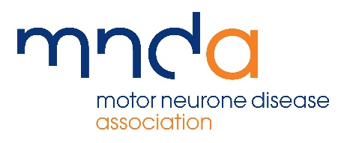 |  | 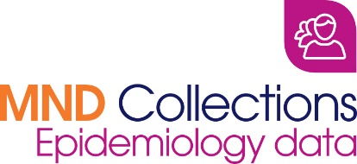

BIOMEDICAL RESEARCH ADVISORY PANEL
APPLICATION FORM
REQUEST FOR ACCESS TO EPIDEMIOLOGY DATASET, UK MND Collections

Please fully complete and sign the application form and return, along with supplementary information to:

Sarah Thompson
Research Co-ordinator (Abstracts and Collections)
Email: mndcollections@mndassociation.org
Tel: 01604 611 692

Before completing the form please read the Terms and Conditions for Use, key paragraphs of which are given in brackets in some questions below.

- Title of Project:

Name of all applicants, affiliations and contact details:

- Principal Applicant

  - Preferred Title:

  - Forename(s): Surname:

- Contact Details

  - Department:

  - Institution:

  - Address:

  - Telephone No: Facsimile No:

  - Email:
- Co-applicants (please duplicate if there are more than two applicants)

  - Preferred Title:

  - Forename: Surname:

  - Institution:

  - Address:

  - Telephone Number: Facsimile Number:

  - Email Address:

Project Details

- Planned/known source of funding, eg MRC. Please include decision dates for applications pending and grant references(see paragraphs 3.1-3.6 and 3.9-3.12)

- Has the research proposed been subjected to peer review?
If yes please provide details, eg funding body etc. (see paragraphs 3.7 and 3.8))

- Does the study have Ethics Committee approval?
If yes, please give the reference number and date of approval. (see paragraphs 3.13 -3.15)

- Please give a brief description of the project (max 1000 words, including justification for use of the data, background, objectives, research question, study design, cohort definition and method of analysis)

- Please give details of the anticipated start date for the analysis of the data / start of the project

- How long will the project take to complete from receipt of data?

Requested epidemiology data

- Details of the data you are applying to use

Please list the fields of data you would like to use. (see Appendix 3 of the Terms and Conditions of Use for details of the fields available).

Additional phenotypic information. All approved requests for Epidemiology Dataset will also receive a copy of the minimum dataset and the additional phenotypic information stored for those participants that also participated in the DNA and cell bank study. (See sections 10.5 – 10.8 in the Terms and Conditions for Sample Use for more information on these datasets).

- Do you require access to samples within the DNA and cell bank collection? (Please delete as appropriate)

Yes / no

13 If yes, does a DNA and Cell Bank form accompany this Epidemiology Dataset form? (Please note questions 8 – 12 of the DNA and cell bank form should be completed for all requests to access the samples)

- Declaration

I have read the UK MND Collection Terms and Conditions for Use and agree to abide by them and any amendments which may subsequently be issued. I shall be actively engaged in, and in day to day control of the project.

I agree to allow the Motor Neurone Disease Association to hold the details contained on this form in their records and for these details to be released to the Biomedical Research Advisory Panel and other appropriate bodies.

Signature:

Date:

