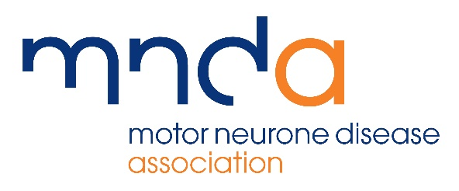

BIOMEDICAL RESEARCH ADVISORY PANEL
APPLICATION FORM
REQUEST FOR ACCESS TO DNA and Cell Bank, UK MND Collections

Please fully complete and sign the application form and return, along with supplementary information to:

Sarah Thompson
Research Co-ordinator (Abstracts and Collections)
Email: mndcollections@mndassociation.org
Tel: 01604 611 692

Before completing the form please read the Terms and Conditions for Use, key paragraphs of which are given in brackets in some questions below.

- Title of Project:

Name of all applicants, affiliations and contact details:

- Principal Applicant

  - Preferred Title:

  - Forename(s): Surname:

- Contact Details

  - Department:

  - Institution:

  - Address:

  - Telephone No:

  - Email:
- Co-applicants (please duplicate if there are more than two applicants)

  - Preferred Title:

  - Forename: Surname:

  - Institution:

  - Address:

  - Telephone Number:

  - Email Address:

Project Details

- Planned/known source of funding, eg MRC. Please include decision dates for applications pending and grant references(see paragraphs 3.1-3.6 and 3.9-3.12)

- Has the research proposed been subjected to peer review?
If yes please provide details, eg funding body etc. (see paragraphs 3.7 and 3.8))

- Does the study have Ethics Committee approval?
If yes, please give the reference number and date of approval. (see paragraphs 3.13 -3.16)

- Please give a brief description of the project (max 1000 words, including justification for use of the samples, background, aims, materials and methods, analysis and references)

- Please give details of the anticipated start date for the project and/or sample use

- How long will the project take to complete from receipt of samples?

Requested Sample Details

- Details of the samples you are applying to use

Please complete the table with the numbers and type of sample you are applying to use (eg person with MND, 150 DNA samples).

Type of sample | Numbers of samples:
 | DNA | Familial  Cell lines | Sporadic Cell lines | Other*
Person with MND
Control
Other participant type*

*Please see Terms and Conditions for use for more details.

- Additional information on sample selection. Please provide as much information as possible regarding sample selection, eg if chosen more than one sample type, are the same sample IDs required? If requesting DNA, what concentration and amounts?

Clinical data accompanying samples:
All samples will be accompanied by the minimum dataset. Further information, referred to here as the extended dataset, has also been collected. Please see paragraphs 10.5 to 10.8 of the Terms and Conditions for Sample Use for more information.

Researchers wishing to access the additional phenotypic data must first liaise with principal investigators to explore collaborative opportunities. However, formal collaboration may not be required for access to the extended dataset.

These data were acquired from participants where possible, it is not a complete dataset for all participants. Thus requesting data from the extended dataset may restrict the number of samples available.

- Do you require access to additional phenotype information?

  - Yes / No

(If yes, please complete Q14 and Q15. If no, please go to Q16)

- Please give details of the discussion with the PIs regarding collaboration to use the extended dataset.

- Please specify below the fields you require; the rationale for doing so and the order of priority in which these are useful, where 1 is the top priority.

 | Field | Rationale
Priority 1
Priority 2
Priority 3

- Have you also submitted an application form to access the epidemiology dataset

Yes / No

If Yes, please ensure that both forms are submitted to the MND Association together.

- Declaration

I have read the UK MND Collection Terms and Conditions for Use and agree to abide by them and any amendments which may subsequently be issued. I shall be actively engaged in, and in day to day control of the project.

I agree to allow the Motor Neurone Disease Association to hold the details contained on this form in their records and for these details to be released to the Biomedical Research Advisory Panel and other appropriate bodies.

Signature:

Date:

